**User Manual**

Create website account

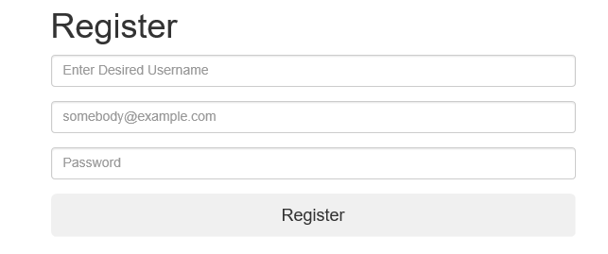

* Load the register.php page using the website’s navigation bar.
* Input data into the “pages input” form and press submit.
* The form will not be submitted until all the fields are filled in.
* An error message will appear if the input username and email are inside the website’s database.
* A confirmation message will appear after the user has been registered.

**Blog**

Load blog

* Press the “Blog” hyperlink in the website navigation bar after you have logged to the website.

Show blog posts for one category

Press the hyperlink in the blog categories side navigation bar on the “blog.php” page or via the website’s navigation bar.



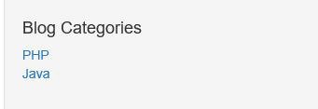

Show blog posts on next page

A maximum of five blog posts will appear on the “blog.php” page.

To navigate to the additional posts, press the pagination (numbers) at the button of the page.

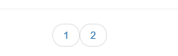

Load individual blog post pages

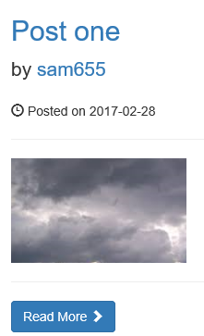

Press the hyperlink inside the post name (or the “Read More” button) and the individual post page will load.

Add comment to blog post

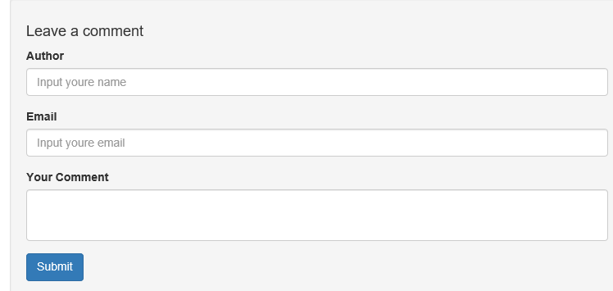

* Load the individual post page.
* Input data into the “Leave a comment” form and press submit button.
* The form will not be submitted until all the fields are filled in.
* The values in the form will disappear when the form is sent.

**Website Content Management System (CMS)**

Login to website - Content Management System

* When a website user with administrator privileges is logged in a hyperlink to the CMS will appear in the website navigation bar.
* Press the link and the dash board of the CMS will load.

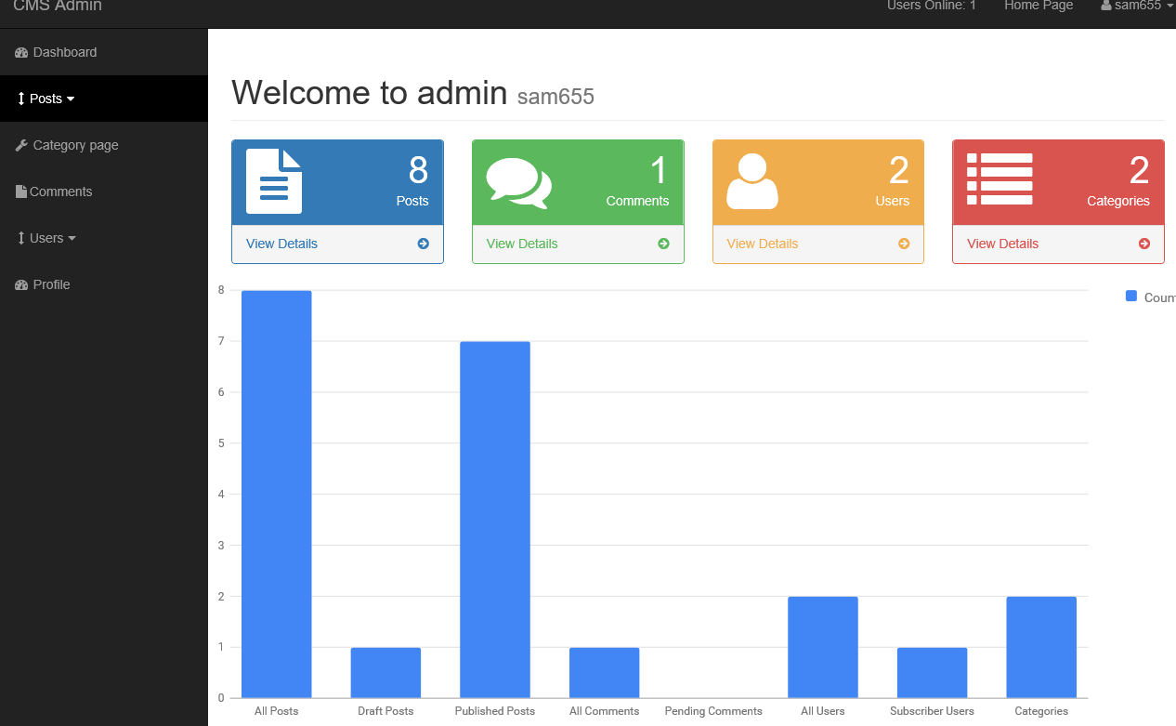

Navigate to main site index page

* Press the Home Page hyperlink in the navigation bar.

**Blog posts CMS page**

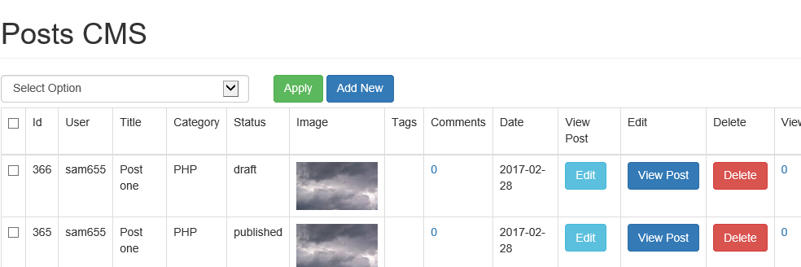

The Posts page will be used to control all the posts in the website’s blog.

To load the Posts page, press the View All Posts hyperlink in the Post’s drop down menu.

Posts page – delete a post

* To delete one post, press the Delete Post button.
* To delete multiple posts right click on the tick boxes next to the rows being deleted.
* Select delete from the Select Options drop down list and press the Apply button.

Posts page – reset number of post views

The number of times each post has been viewed will be displayed in the View column. To reset this value to zero, press the number in the View column.

Posts page – view individual post comments

The number comments on the individual posts will be displayed in the comments column. To load the page which shows the comments press the number in the Comments column.

Posts page – add post

* To add a post, press the Add New button or Add Post hyperlink in the Posts dropdown menu.
* The page that is used to add a post will load.

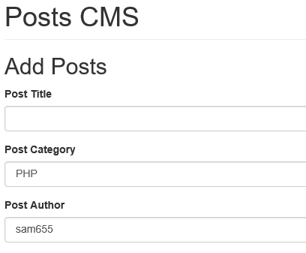

* Fill in all fields and press the “add post” button.

Posts page – edit post

* Press the Edit post button in the Edit column.
* The page that is used to edit a post will load.
* Edit the Post fields and press the Edit Post button.

Posts page – clone post

* To clone a post, right click on the tick boxes next to the rows that are being cloned.
* Select Clone from the Select Options drop down list and press the Apply button.

Posts page – view post

Press the View Post button and the individual post page will load.

**Blog quizzes CMS page**

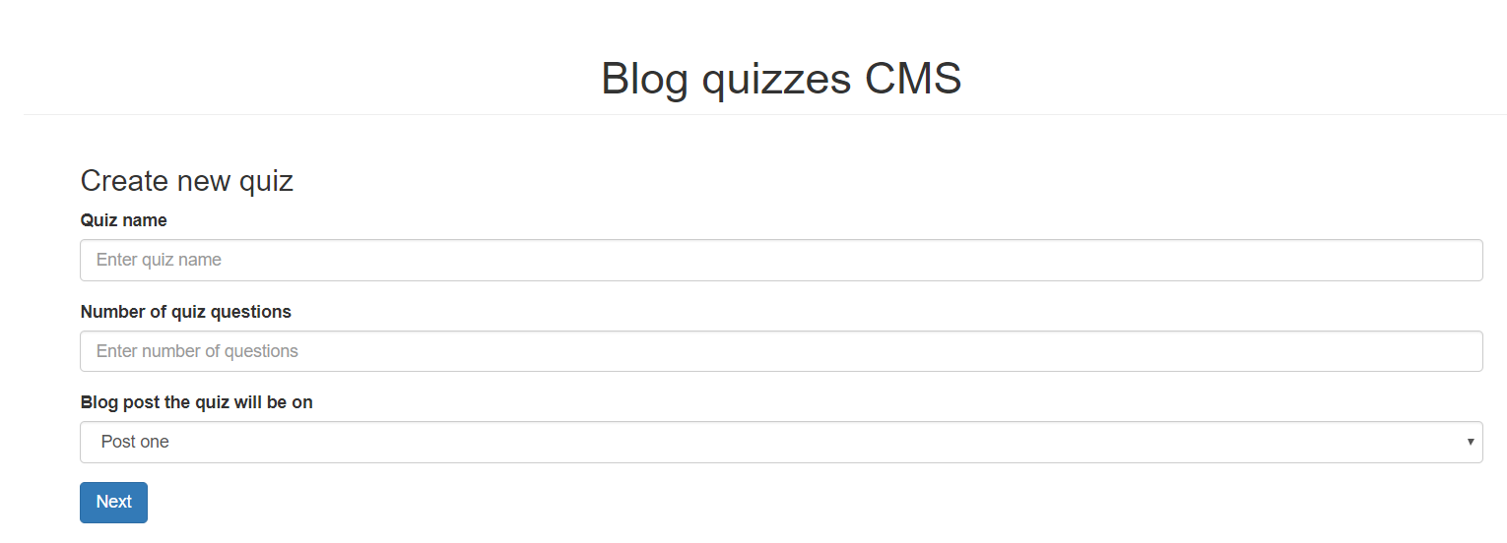

The “quiz_cms.php page” is used to create website quiz.

To load the “quiz_cms.php page, press the “Create blog quiz CMS” hyperlink in the side navigation bar.

Add quiz

* Input the quiz name the post the quiz will appear on, and number of quiz quesions into the “Quiz Name” “Blog post the quiz will appear on” and “Number of quiz questions” input boxes, and press the “Next” button.
* Input the quiz answers and question into the form that appears and press the “Next” button.

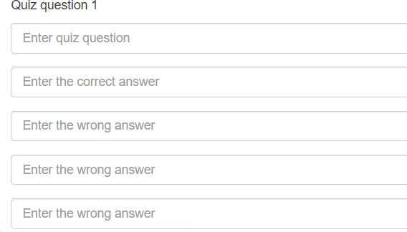

* A confirmation message will appear when a quiz has been added successfully and the quiz will appear on the selected blog post.
* When nothing is input into the input boxes an error message will appear.

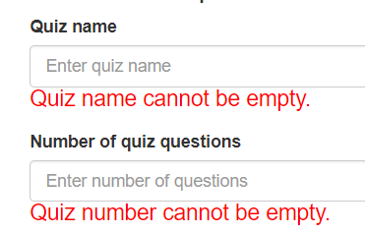

* A confirmation message will appear when a category has been added successfully and the category will appear in the Current Categories menu.

**Blog categories page**

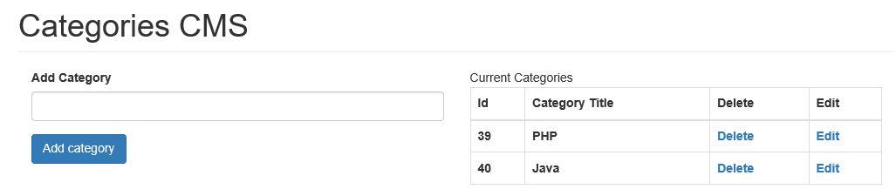

The categories.php controls the categories from the blogs posts.

To load the categories page, press the Categories hyperlink in the side navigation bar.

Categories page - add category

* Input the category name into the Add Category input box and press the Add button.
* When nothing is input into the Add Category input box an error message will appear.
* A confirmation message will appear when a category has been added successfully and the category will appear in the Current Categories menu.

Categories page - update category

* Press the Edit link in the Current Categories menu (a form which is used to update the selected category will appear).

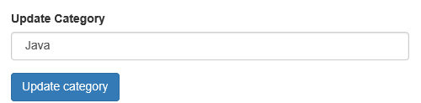

* Make the modification and press the Update Category button (the Update category form will disappear).

Categories page – delete category

Press the Delete button in the Current Categories menu.

**Users page**

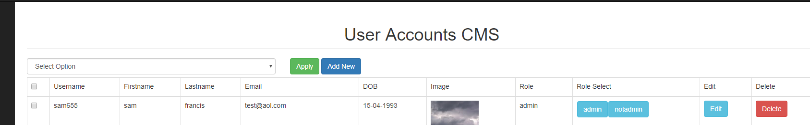

The Users page will be used to control the user accounts from the website.

To load the User Page, press the View All Users link in the users drop down menu.

Userspage – delete a user

* To delete one user, press the Delete button.
* To delete multiple users right click on the tick boxes next to the rows being deleted.
* Select Delete from the Select Options drop down list and press the Apply button.

Userspage – add user

* To add a user, press the Add New button or Add User hyperlink in the side navigation bars Users dropdown menu.
* The page that is used to add a user will load.

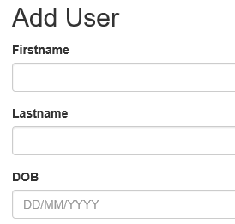

* Fill in all fields and press the Add User button.

Userspage – edit user

* Press the Edit User button in the edit column.
* The page that is used to edit a user will load.
* Edit the user field and press the “edit user” button.

Userspage – change user status

Users can have two statuses “admin” and “notadmin”.

Users with Administrator privileges will have access to the CMS pages

* To change the status of one user, press the Subscriber or Admin buttons in the Role Select column of the Administrator User Accounts CMS table.
* To change the status of multiple user, right click on the tick boxes next to the user being updated, select Subscriber or Admin from the select options drop down list and press the Apply button.

**Index page CMS page**

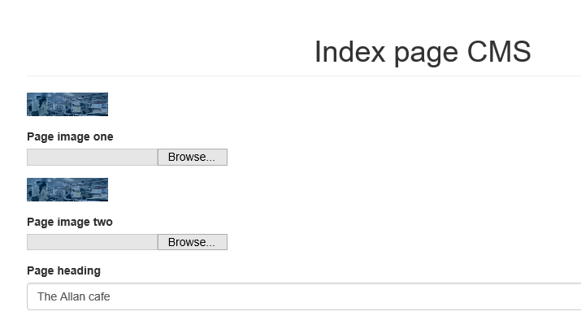

Changing details on this page controls what appears on the Index page.

* The text / images input into the text boxes will be displayed on the Index page.
* An error message will appear if a user tries to upload a fake image.

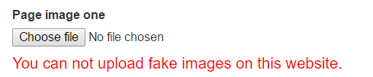

* If a user inputs a “~ “into any of the text boxes, the input values will not be displayed property on the Index page.
* Bullet point list items that do not have full stops in front of them will not be displayed on the Index page (a tool tip explaining this will appear when the user hovers over the bullet list title and text boxes).

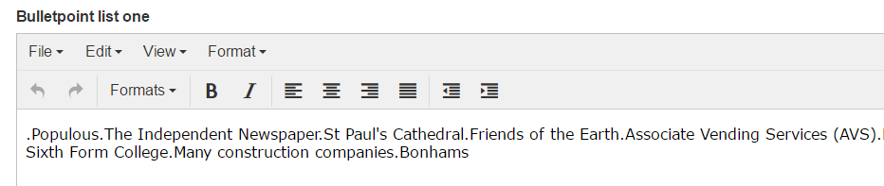

* Press Submit to add the input values to the Index page.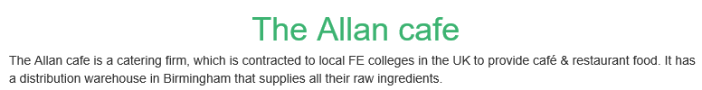

**Blog posts CMS user data page**

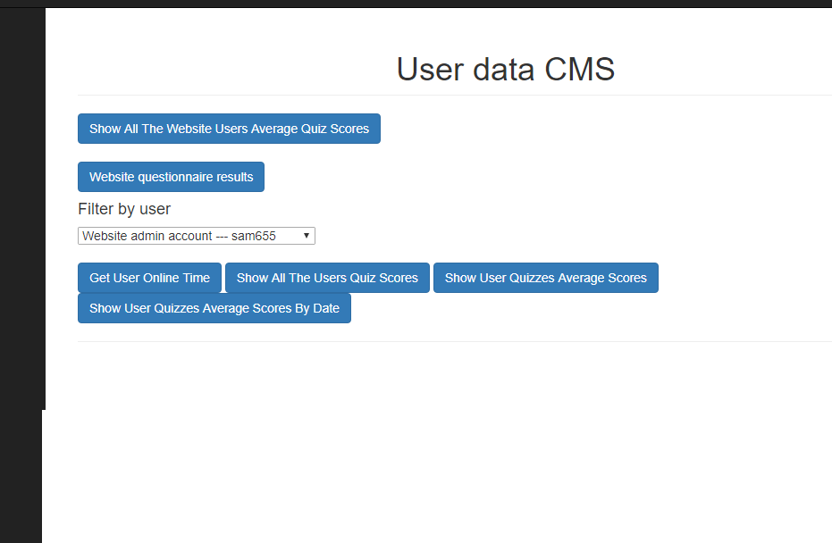

This page will show the results from the website quizzes and the time website users have spent logged onto the website.

Show website users online time

* Select a website user from the “Filter by user” drop down menu.
* Press the “Get Users Online Time” button and the user’s online time will be displayed.

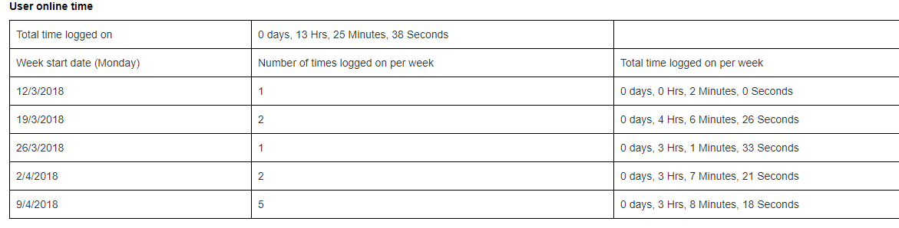

Show all the quiz results for one website user

* Select a website user from the “Filter by user” drop down menu.
* Press the “Show All The Users Quiz Scores” button and the user’s quiz scores will be displayed.

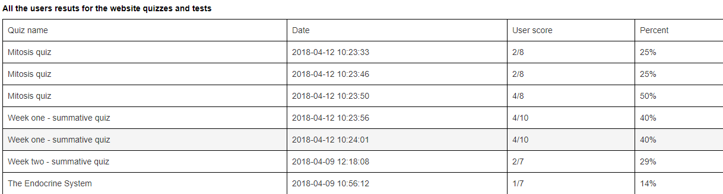

Show the average scores for individual website quizzes for one website user

* Select a website user from the “Filter by user” drop down menu.
* Press the “Show Users Quizzes Average Scores” button and the user’s quiz scores will be displayed.

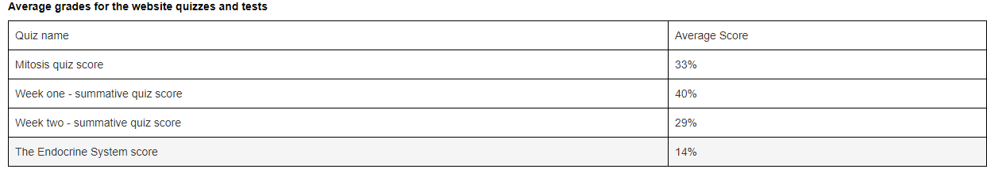

Show the average scores for individual website quizzes for one website user per week

* Select a website user from the “Filter by user” drop down menu.
* Press the “Show Users Quizzes Average Scores By Date” button.
* The user average score for quizzes conducted per week will be displayed in a table and a line chart.

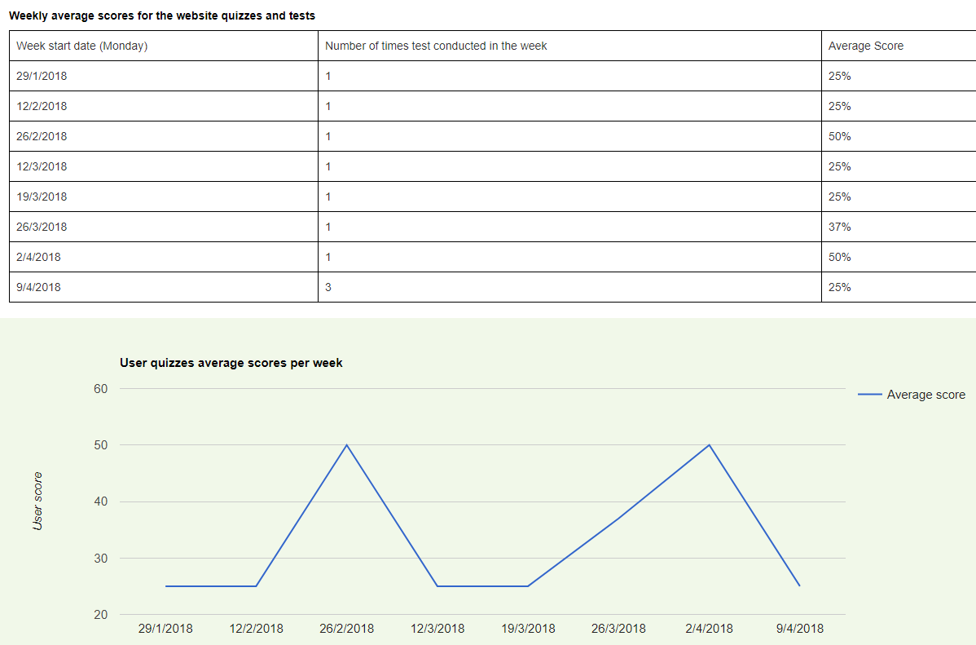

Show the average scores for individual website quizzes

* Press the “Show All The Website Users Average Quiz Scores” button.
* Select a quiz from the “Select Quiz” drop down menu and a bar chart of the user ravage scores will be displayed.

Show the results from website questionnaire

* Press the “Show Questionnaire Results” button and the results will be displayed in a stacked bar chart.